* **Lenslet Array**

**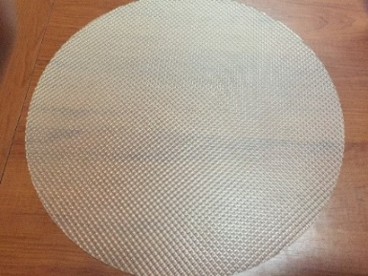**

**We  produced Lenslet Array for**

**\* Microelectronic Systems**

**\* Daylight Lighting Systems**

Microlens arrays are commonly used for homogenizing and shaping a variety of modern light emitters ranging from a line-narrowed excimer lasers to high power LEDs. These microlens arrays are manufactured using photolithographic techniques based on semiconductor processing technology, yielding exceptionally accurate lens profiles and lens positioning.

• Microlens arrays for fiber coupling and optical switching

• Microlenses for collimation of laser diodes and VCSELs

• Microlens arrays for imaging and sensor systems

• Beam homogenizers for high-power lasers and illumination

• Array optics with precise lens positioning

• High-class lens quality (aspherical lens profiles)

• Significant reduction of degrees of freedom in the assembly.

• Developing of Digital Camera

• Developing of Stanhope lenses

• Developing of Photocopiers

Applications Microlenses are used for the collimation, focusing or imaging of light. For example, a microlens images the light from a bundle of single mode optical fibers into an optical switching device and back in another fiber bundle. The high precision of the lateral array dimensions (better than ± 0.25 µm) allows a very accurate fiber-to-lens positioning in one step. The high-class lens quality and the exceptional lens-to-lens uniformity ensure optimum coupling efficiencies for all optical channels in parallel. Aspherical lens profiles are used to minimize the spherical aberrations for different optical configurations.

Imaging illumination systems, whether single- or double-lens systems, paraboloidal reflector and lens systems, or single ellipsoidal reflector systems, all suffer from possible nonuniformities in intensity (and consequently also in irradiance). These are due, among other causes, to possible nonuniformities in the source as well as obstructions such as filament support wires, gas discharge electrodes, and [LED](https://spie.org/publications/fg11_p26_light_emitting_diodes) heat-sink structures.

These nonuniformities can be smoothed out by using a lenslet array, an array (usually 2D) of small lenses. Typically, the arrays are used in pairs. In the diagram below, the dotted purple lines show the [marginal rays](https://spie.org/x33110.xml) for one of the lenslets in the first array; the black dotted lines show the [marginal rays](https://spie.org/x33110.xml) for the corresponding lenslet in the second array.

**Custom products are being developed in Lenslet array.**

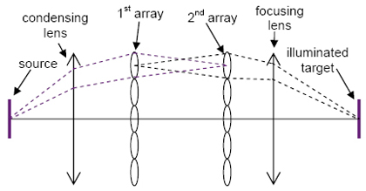 **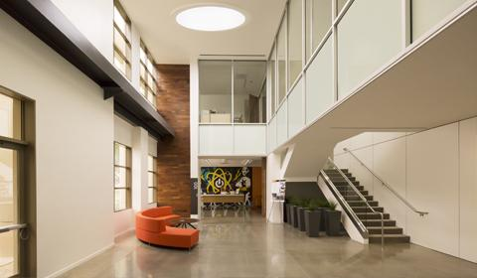**

[**Lenslet Array Video**](https://www.youtube.com/watch?v=Fs1RXQOJwqE)**1**

[**Lenslet Array Video2**](https://www.youtube.com/watch?v=3X2UeGv1QKg)

* **Sun Light Tube Systems**

**How does it work?**

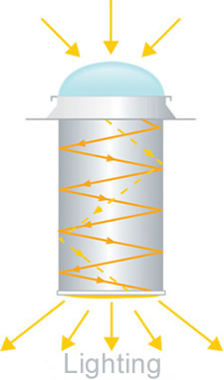

1. Special polycarbonate dome placed on the roof, passes the daylight on reflecting pipe.

2. Daylight which is entering into the pipe system, thanks to the high reflectivity of the pipe, is transmitted like a mirror to the reflecting diffuser.

3. Diffuser distributes the daylight in a homogenous way and provides natural lighting.

**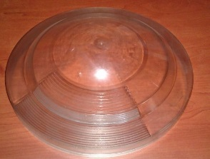 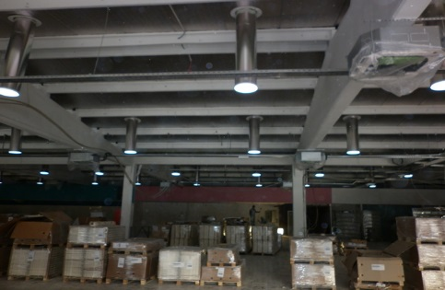**

**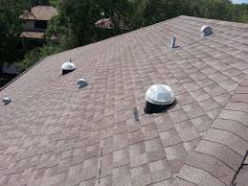 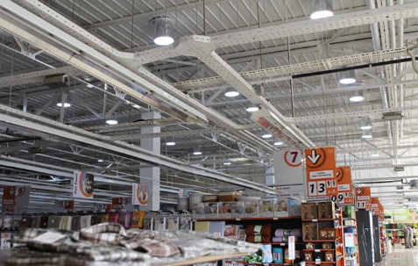**

**\*Ø250mm, Ø350mm,  Ø550mm, Ø900mm**

**\*Meets International Standards**

**\*Cost Efficiency**

**MODELS**

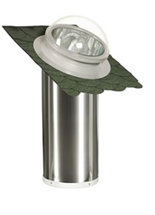SV-250, SV-350, SV-550, and SV-900 types are produced for places like home, office, bathroom, corridors, garages, factories, exposition areas, Lecture Hall, Market. SV-250 meets the requirements of small places with natural light with its esthetic structure, high lighting performance, strength and easy installation.

**Technical Details**

• Polycarbonate dome with high light transmission.  
• Reflective channel with high reflecting coefficient and UV resistant.  
• Acrylic diffuser with high light transmittance and homogeneous light distribution.  
• Accessories provide easy installation for different architectural needs.

**Performance Values**

**SV - 250**

|  |  |
| --- | --- |
| **LIGHTING AREA:** | • 15-20 m2 |
| **EUIVALENT POWER:** | • 150 Watt |
| **ROOF TYPE TO FIX:** | • FLAT • ANGULAR • WOODEN • ALUMINIUM SANDWİCH PANEL |
| **CEILING TYPE TO FIX:** | • OPEN • CLOSED |
| **DIFFUSER TYPE:** | • PRISMATIC / LİNEAR |
| **ACCESSORIES:** | • DİMMER  • LIGHT KIT • ELBOWS • CLOSED CEILING DIFFUSOR • ROOF TOP EXTENSION TUBE |

**Application Areas**

Garages, Offices, Bathrooms, Corridors, Entries, Rooms, Kitchens, Bedrooms, Laundries.

**SV – 350**

|  |  |
| --- | --- |
| **LIGHTING AREA:** | • 20-25 m2 |
| **EUIVALENT POWER:** | • 250 Watt |
| **ROOF TYPE TO FIX:** | • FLAT • ANGULAR • WOODEN • ALUMINIUM SANDWİCH PANEL |
| **CEILING TYPE TO FIX:** | • OPEN • CLOSED |
| **DIFFUSER TYPE:** | • PRISMATIC / LİNEAR |
| **ACCESSORIES:** | • DİMMER  • LIGHT KIT • ELBOWS • CLOSED CEILING DIFFUSOR • ROOF TOP EXTENSION TUBE |

**Application Areas**

Garages, Offices, Bathrooms, Entries, Rooms, Kitchens, Bedrooms, Laundries.

**SV – 550**

|  |  |
| --- | --- |
| **LIGHTING AREA:** | • 30-35 m2 |
| **EUIVALENT POWER:** | • 400 Watt |
| **ROOF TYPE TO FIX:** | • FLAT • ANGULAR • WOODEN • ALUMINIUM SANDWİCH PANEL |
| **CEILING TYPE TO FIX:** | • OPEN • CLOSED |
| **DIFFUSER TYPE:** | • PRISMATIC / LİNEAR |
| **ACCESSORIES:** | • DİMMER  • LIGHT KIT • ELBOWS • CLOSED CEILING DIFFUSOR • ROOF TOP EXTENSION TUBE |

**Application Areas**

Garages, Offices, Bathrooms, Corridors, Entries, Rooms, Kitchens, Bedrooms, Laundries.

**SV – 900**

|  |  |
| --- | --- |
| **LIGHTING AREA:** | • 50-60 m2 |
| **EUIVALENT POWER:** | • 750 Watt |
| **ROOF TYPE TO FIX:** | • FLAT • ANGULAR • WOODEN • ALUMINIUM SANDWİCH PANEL |
| **CEILING TYPE TO FIX:** | • OPEN • CLOSED |
| **DIFFUSER TYPE:** | • PRISMATIC / LİNEAR |
| **ACCESSORIES:** | • DİMMER  • LIGHT KIT • ELBOWS • CLOSED CEILING DIFFUSOR • ROOF TOP EXTENSION TUBE |

**Application Areas**

Factories, Stock Rooms, Exposition Areas, Lecture Hall, Markets, Car Park, Fitness Center

**ACCESSORIES**

**Dimmer**

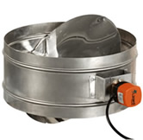This accessory allows the dimming of the daylight, when it is not requested at day time. On/off controlled flap cut off daylight transmittance.Application areas: Meeting and seminar rooms, bedrooms etc.

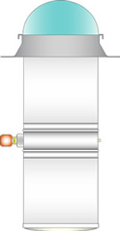

**Artificial Lighting Kit**

This kit is installed inside the Sunvia Daylighting System and provides lighting at evening and night times when there is no daylight.

**Note: For SV-250 and SV-350 models only.**

**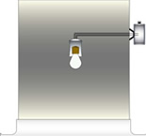**

**Adjustable Tube**

Adjustable tube is an optional part with high reflectivity rate to transfer the light, that can be adjusted manually at locations where curves are during installation. Adjustable tubes are made with 0 – 45 angles.

**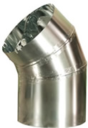**

**Elbows**

This accessory is made from the same material of reflective channel and it allows the pipe to be turned to different directions.

**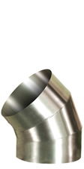 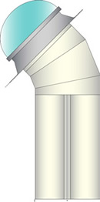 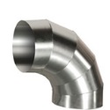**

**Angular Roof Flashing**

Angular roof flashing holds the dome straight for maximum benefit from sunlight if the building direction is not looking south. It is made of electro-static painted galvanized sheet.

**C:\Users\user\Desktop\img_25.jpg 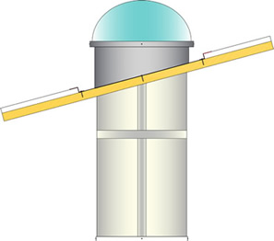**

**Close roof diffuser**

Easily installed esthetic type diffuser for home, school, hospital and office. There are 2 types of diffusers, which are round and square.

**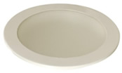 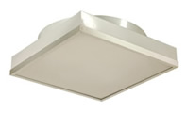**

**Roof-top Extension Tubes**

These are the accessories used for roofs with shadows. It extends the dome to benefit from the sunlight.

**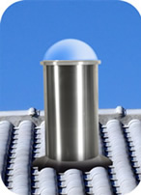 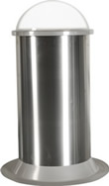**

**Why Daylighting?**

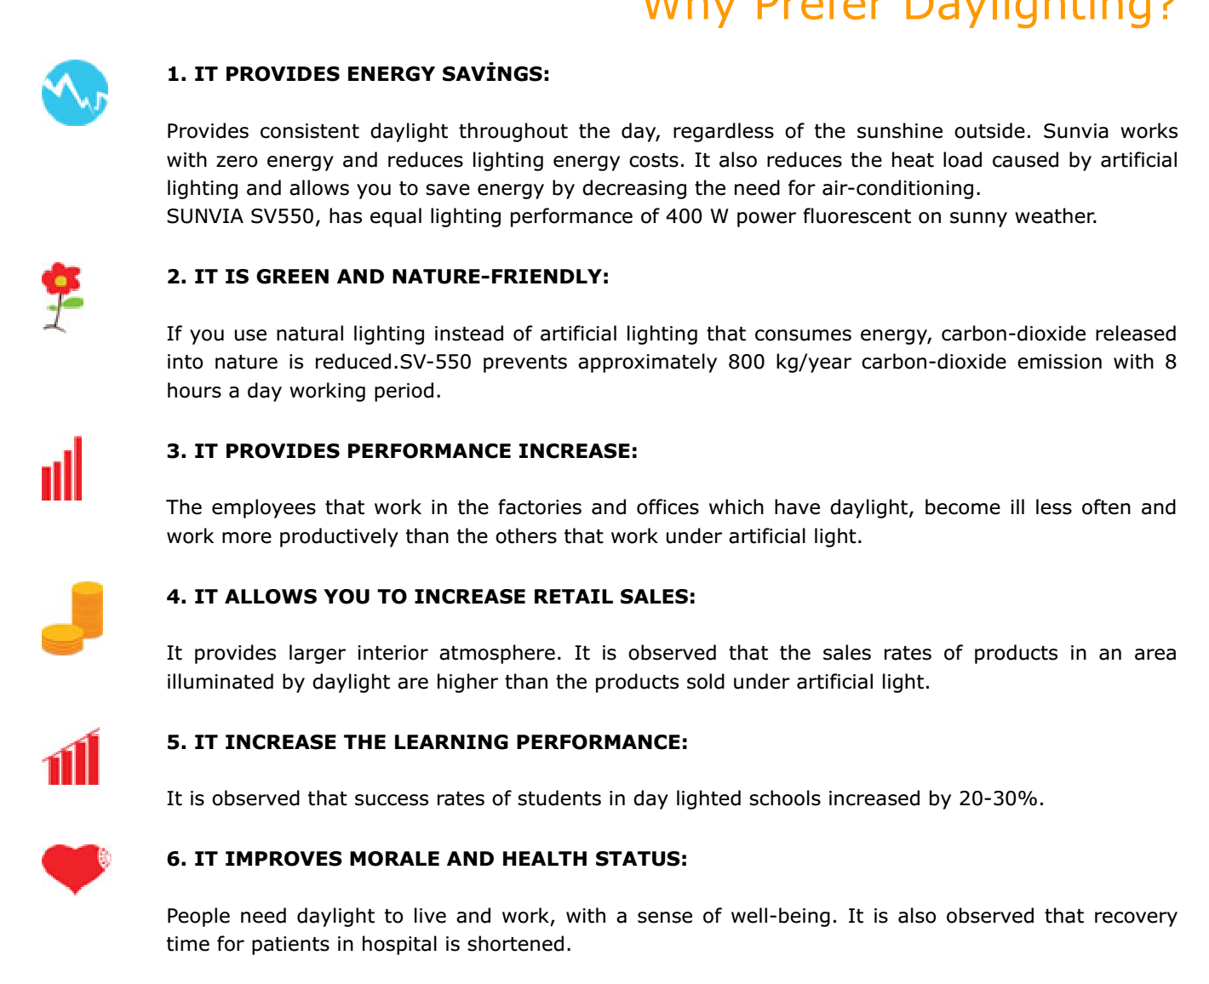

**A Technical Summary**

**A. Tubular Daylighting Devices & Dome Lenses**

Dome lenses are the main part of the tubular daylighting devices that focus and deliver the optimal amount of natural light as a high-performance lighting solutions that bring daylight into interior spaces where traditional skylights and windows simply can’t reach. Tubular daylighting devices harvests natural light from sunup to sundown by using a rooftop dome lens and transfers it to interiors through reflective tubing. Kuantumek is the global leader especially dome lens don’t need to aluminium reflector unit to focus and collect horizontally scattered light.



**B. Next-Generation Dome Lenses**

Kuantumek Technology developed and manufactured next-generation dome lenses by using a novel optical design which combines 270 degrees Fresnel lens and 90 degrees reflector lens designs into the same unit. 270 degree Fresnel lens part of the dome lens have a unique optical design that enables to harvest sunlight optimally from any solar angle. As a result, it controls sunlight more effectively than systems with active sun tracking technology. It has no moving parts and yet it transfers daylight more efficiently and delivers better color rendition than active systems due to the nature of its complex Fresnel lens design. 90 degrees reflector lens of the next-generation unit replace the aluminum reflector of the classical dome lenses to focus and collect the horizontally scattered sun light more efficiently without the need of any additional accessories.

Next-generation dome lenses are manufactured by using an advanced high quality plastic injection technique. Design and optimization of the injection molds are developed by using optical design and plastic injection simulations. Plastic injection molds of the next-generation dome lenses are developed by using advanced nanoscale surface coating technology. This nanoscale coating provides a smooth transition between the refractive indexes of polycarbonate material and air, successfully eliminating the boundary between substantially different refractive indexes. Furthermore next-generation dome lenses have significantly low manufacturing and operating costs because of their unique single unit design instead of the modular structure of the classical dome lenses.

**C. Solar Panel Applications of Next-Generation Dome Lenses**

Kuantumek Technology recently begun to develop solar panel applications of next-generation dome lenses by scaling down the radius of the lenses to fit inside a standard photovoltaic solar cell. Kuantumek Technology aims to bring the unique optical properties of next-generation dome lenses to solar panels to increase the energy efficiency of solar panels by collecting the maximum solar energy from any solar angle. Novel optical design of the 270 degree Fresnel lens part of the dome solar cell lens enables to harvest sunlight optimally from any solar angle. Thereby, it will control sunlight more effectively than any systems without using an active sun tracking technology. Also, 90 degree reflector lens of the dome solar cell lens focus and collect the horizontally scattered sun light without usage of any additional accessories.

D. Figures

Designs of Kuantumek Technology’s Next-Generation Dome Lenses are demonstrated in the following figures:

**Figure 01 - Next-Generation Dome Lens Front & Top**

1. **Next-Generation Dome Lens Front B. Next-Generation Dome Lens Top**

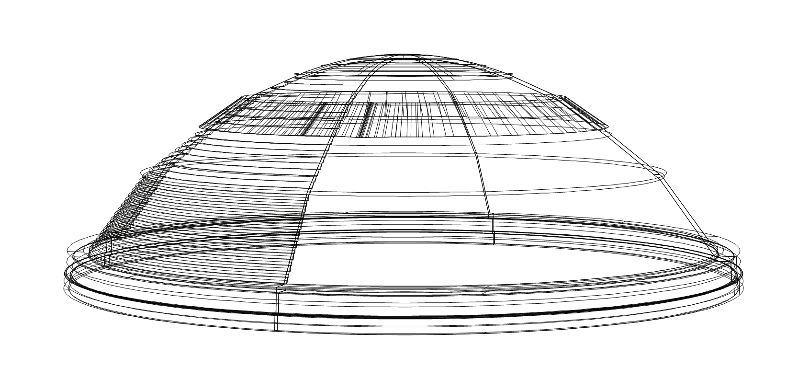 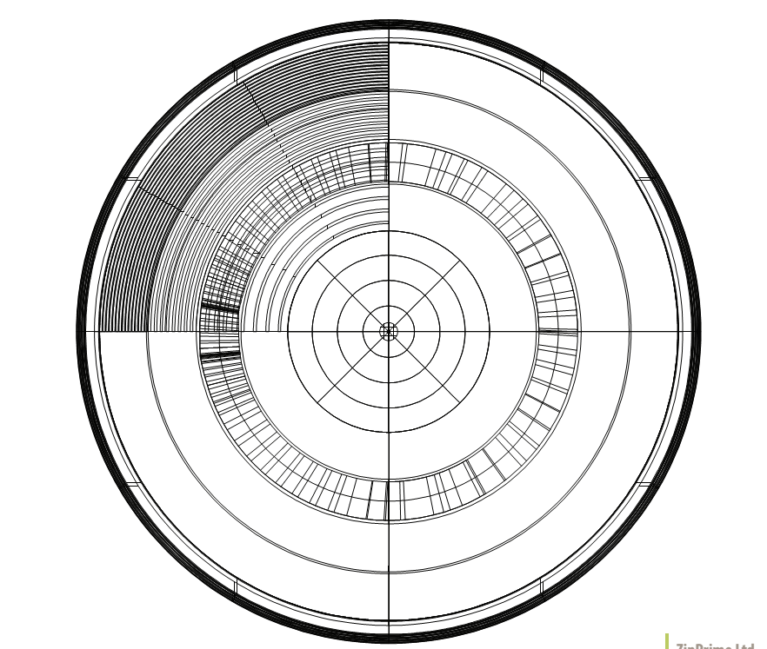

**Figure 02 - Next-Generation Dome Lens Right & Left**

1. **Next-Generation Dome Lens Right B.Next-Generation Dome Lens Left**

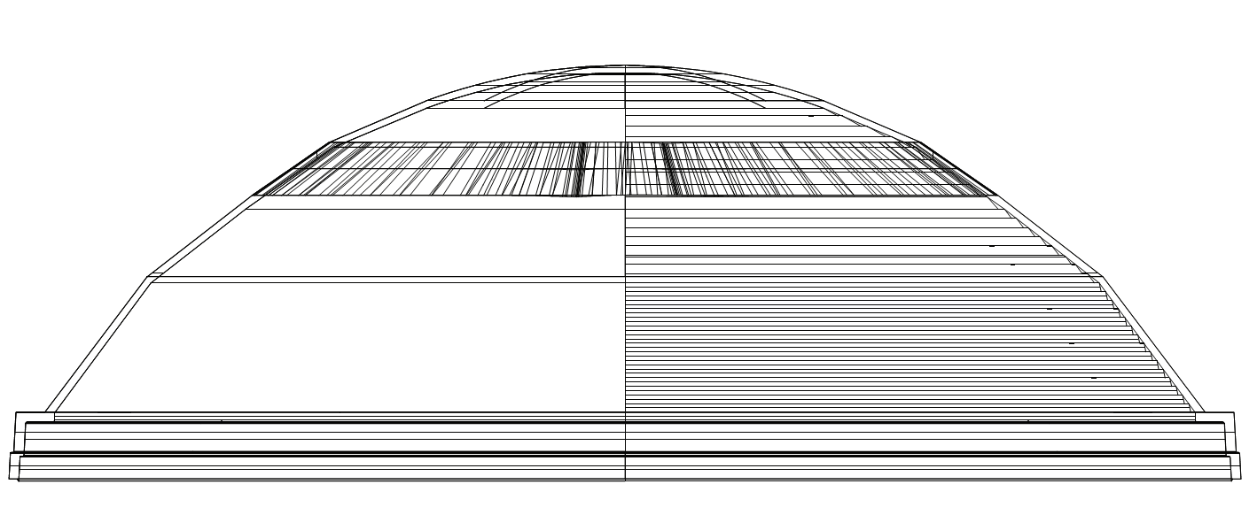 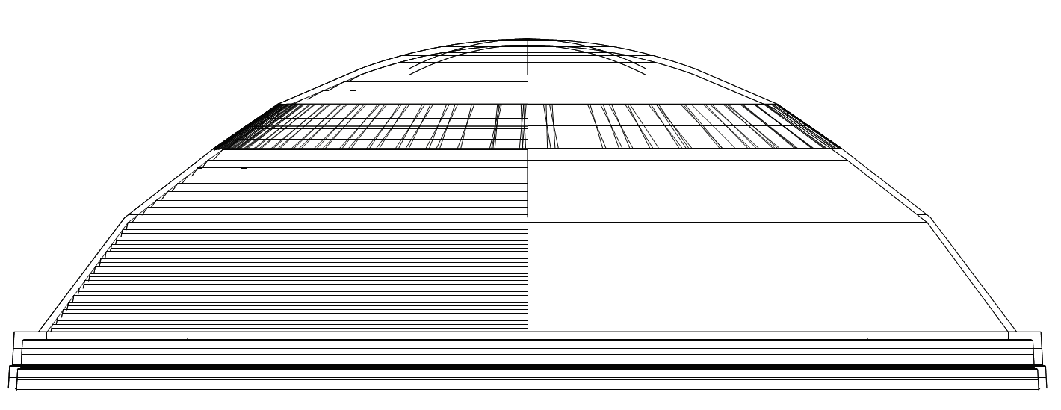

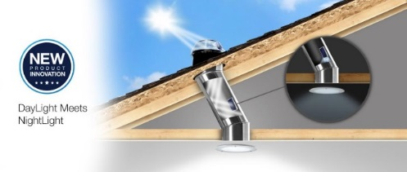 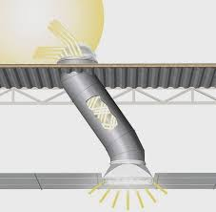

**TECHNICAL SPECIFICATIONS**

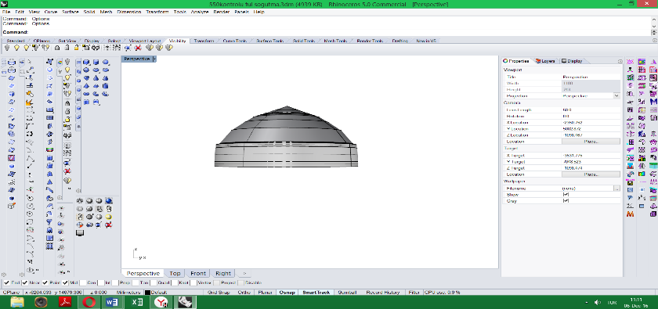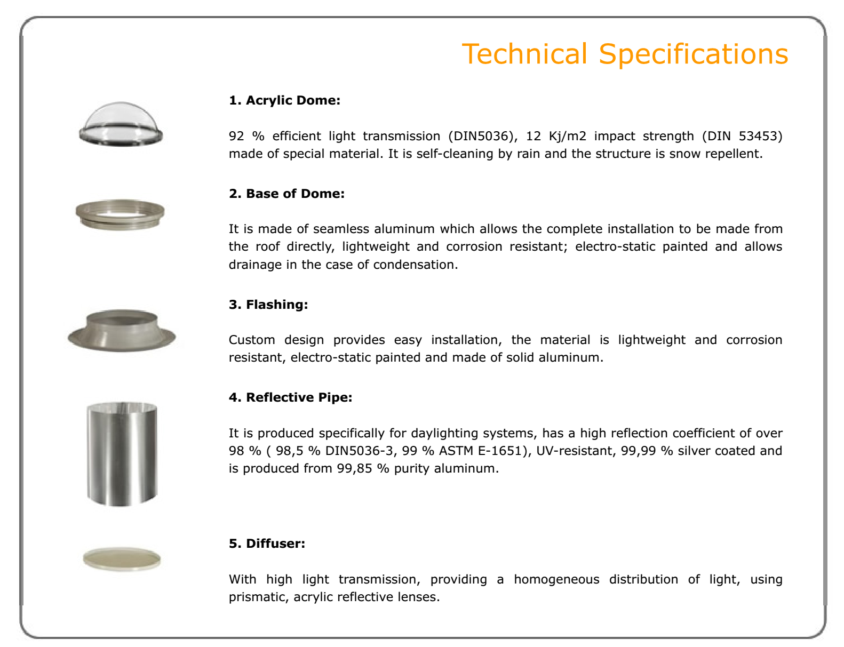

1. **Polycarbon Dome Lens**

89 % efficient light transmission (Sabic), 12 Kj/m2 impact strength (Sabic) made of special material. It is self-cleaning by rain and the structure is snow repellent.

1. **Base of Dome**

It is made of seamless aluminum which allows the complete installation to be made from the roof directly, lightweight and corrosion resistant; electro-static painted and allows drainage in the case of condensation.

1. **Flashing**

Custom design provides easy installation, the material is lightweight and corrosion resistant, electro-static painted and made of solid aluminum

1. **Reflective Pipe**

It is produced specifically for daylighting systems, has a high reflection coefficient of over 98 % ( 98,5 % DIN5036-3, 99 % ASTM E-1651), UV-resistant, 99,99 % silver coated and is produced from 99,85 % purity aluminum.

1. **Diffuser**

With high light transmission, providing a homogeneous distribution of light, using prismatic, acrylic reflective lenses.

[**Dome Lens Systems Video**](https://www.youtube.com/watch?v=Cl6Zxu25ZmE)

[**Assembly Video**](https://www.youtube.com/watch?v=otYzIOSi7SA)

**[Installation Video](https://www.youtube.com/watch?v=MPzRic5hjjU&feature=youtu.be)**

**Documents**

**[Description](https://static.wixstatic.com/ugd/37aebe_a3a262381223477c823996f48b7a1f34.pdf?dn=Description.pdf)**

**[User Manual](https://static.wixstatic.com/ugd/37aebe_c928aa261f054bd59ce4367826f300f1.pdf?dn=SunlightUserManual.pdf)**

**International Patents and Trademark**

**Guarantees**

1. Lenses and Reflective Pipe have 10 years guarantees.
2. Accessories have 2 years guarantees.

* **Fresnel Lens**

**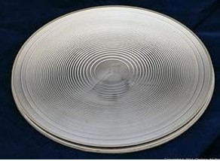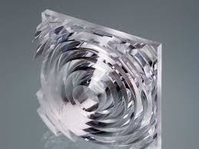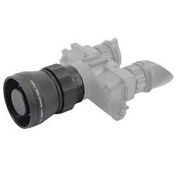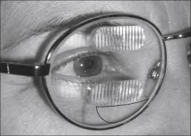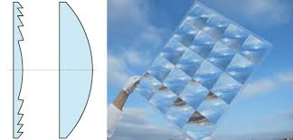**

***We produced Fresnel Lenses for***

***\*Forest Fire Early Warning System***

***\*Medical Applications***

***\*Military Applications***

***\*Developing of the Projection Lenses***

***\*Optical Communications***

The driving principle behind the conception of a Fresnel lens is that the direction of propagation of light does not change within a medium (unless scattered). Instead, light rays are only deviated at the surfaces of a medium. As a result, the bulk of the material in the center of a lens serves only to increase the amount of weight and absorption within the system.

To take advantage of this physical property, 18th-century physicists began experimenting with the creation of what is known today as a [Fresnel lens](http://www.edmundoptics.com/optics/optical-lenses/fresnel-lenses/). At that time, grooves were cut into a piece of glass in order to create annular rings of a curved profile. This curved profile, when extruded, formed a conventional, curved lens – either spherical or aspherical (Figure 2). Due to this similar optical property compared to a conventional optical lens, a Fresnel lens can offer slightly better focusing performance, depending upon the application. In addition, high groove density allows higher quality images, while low groove density yields better efficiency (as needed in light gathering applications). However, it is important to note that when high precision imaging is required, conventional singlet, doublet, or aspheric [optical lenses](http://www.edmundoptics.com/optics/optical-lenses/) are still best.

***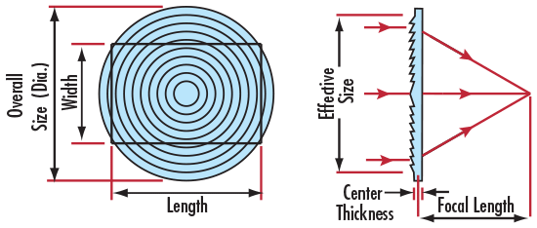 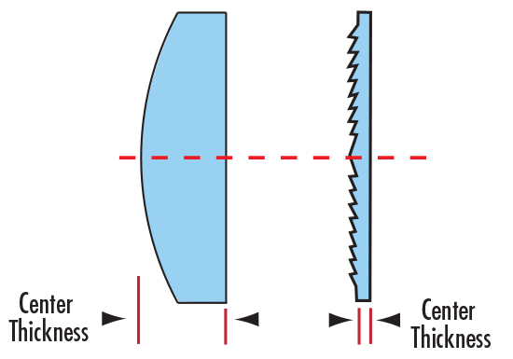***

***Figure 1 Figure 2***

The choice of the optimum parameters of a microlens array depends very much on the actual design and requirements of your optical system.

**Custom products are being developed in Fresnel Lens.**

**International Patents and Trademark**

**Guarantees**

1. Fresnel Lenses have 10 years guarantees.

[**Fresnel Lens Video1**](https://www.youtube.com/watch?v=VyQAg4j-7K4)

**[Fresnel Lens Video2](https://www.youtube.com/watch?v=4MhCYJqkgh8)**

[**Fresnel Lens Video3**](https://www.youtube.com/watch?v=xWMrsqs3bFc)

[**Fresnel Lens Video4**](https://www.youtube.com/watch?v=iMwjoUzfBEs)

* **Power Led Traffic Modules**

**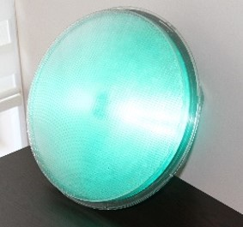 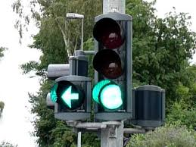 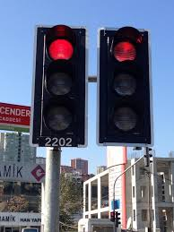 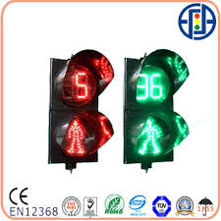**

\*Red, Yellow, Green, Transparent

\*3 Power Leds – 1.5 W/100 Lm

Energy efficiency and clean,renewable energy will mean a stronger economy, cleaner environment,

and greater energy independence for the world. Our products ensure to put a step in this target.

\* Meets TS EN 12368 Standards

\* Energy Saving (up to 90%)

\* Horizontal and Vertical mounting,

\* Long LED life,

\* IP 55 protection in lamp and IP65 protection in module,

\* Opportunity to make combination with 200 mm / 300 mm transmitters,

\* Modular structure,

\* Easily mountable,

\* Different color options,

\* Class IR3 at impact resistance,

\* 100% polycarbonate body resistant to UV rays/lights.

\* Vehicle Signal Lamps: 200 / 300mm

\* Arrow Signal Lamps: 200 / 300mm

\* Pedestrian Signal Lamps : 200/300mm

\* Voltage and Frequency Range: 110/220 V AC (+%15, -%20), 50/60 Hz (±%4)

\* Operating temperature: -40˚ C~+55˚ C

\* Operating temperature: >1.0 ˚ C

\* The traffic light modules are not brightness by reflection of the sun.

**STANDARDS**

TS EN 12368:2006, TS EN 50293

**Material**

UV-Stabilized Polycarbonate

**Dimensions**

200, 300 mm

**Interior Lens**

200, 300 mm Fresnel

Housing Colours Black, Silver Gray, Green, Amber, Combination Colours acc to request

**Front Lens**

Lenslet Array

**Colours**

Transparent, Red, Green, Amber

**Impact Resistance Class IR3 acc. To TS EN 12368**

**Passed Tests Change of Temperature**

Vibration Tests

Damp Heat Tests

EMC/EMI Tests

**Certification**

TS EN 12368:2006

**Protection**

Water and Dust-proof (IP 65 for Module), (IP 55 for Lamp)

**Voltage and Frequency Range**

110/220 V AC (+%15, -%20), 50/60 Hz (±%4)

**Operating Temperature**

-40˚ C~+55˚ C

**International Patents and Trademark**

**Guarantees**

1. Powerled Traffic Lamp Modules have 3 years guarantees.

**[VIDEOS1](https://www.youtube.com/watch?v=PfP5daCV93w)**

[**VIDEOS2**](https://www.youtube.com/watch?v=00Pbrwk40dM)

[**VIDEOS3**](https://www.youtube.com/watch?v=UrVl2Ssk6dY)

* **Led Lens**

**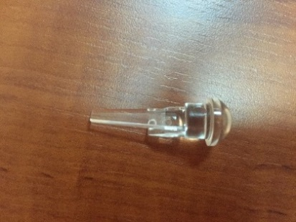** Variable Traffic Signs are used widely for ITS applications and they often used on highways to give travelers information about dynamic situation of the road, like weather information, current speed limit, lane control information. They are usually smaller size according to the VMS and used especially on the critical part of the road network like tunnel entrance, construction zones, meteorologically critical locations, toll collection areas and etc. Kuantumek Technology offer special design according to customer needs and meet the criteria of the potential situation of the road. Variable traffic signs can be with predefined pictograms or full matrix type. Kuantumek Technology system continuously monitor the current situation of the road network like weather conditions, traffic speed and changes the information on the sign automatically without any operator support. Our Variable Traffic Signs also have the plug and play option for most type of traffic situation measurement devices.

**Material: Acrylic; Weight: 250mg; Length: 2cm**

Key Benefits

* Compliance with EN12966
* Custom Matrix design
* Single LENS technology
* Frontal maintenance option
* Low Power Consumption
* Wide variety of communication options
* Compatible with TCP/IP, NTCIP, PROFIBUS, MODBUS protocols
* Intelligent Fault Detection
* Special Frontal Design to avoid the reflection
* Plug & Play option f Multi point support Power Supply Design (Each Power Supplies are spares for each others)
* Single Point Continuous Control
* Easy Maintenance and Installation

Applications

* Bridge
* Building
* Entertainment Center
* Club
* Streets
* Message Boards
* Traffic Signs

Lane Control Signs: Lane control signs are one of the mostly used variable traffic signs and used at the entrance and inside the tunnels and forward drivers to the individual lanes according to the current situation of the each lane in the tunnel. Kuantumek Technology’s standard lane control sign comes with 4 aspect of right arrow, left arrow, down arrow, and cross sing with different and customized size options. Speed Control Signs: Speed control signs are also mostly used at the entrance and inside the tunnels and show the drivers the current speed limit of the road or the tunnel according to the current situation of the traffic flow. Kuantumek Technology’s standard speed control sign comes with 4 aspects of 50, 70, 90 and exclamation sign.

# C:\Users\user\Desktop\Powerled.jpg C:\Users\user\Desktop\LedLens.JPG

# 

# Monitor LED Lens

# C:\Users\user\Desktop\unnamed.png

# INSTALLATION GUIDE

# ) Attached to the Lenses on the Monitoring Systems.

# Monitor Front Plane

# 

# 

# 

# Lens Holder

# Monitor

# Figure1

# Attached to the Leds on the bottom plate

# C:\Users\user\Desktop\LED.jpg (Before Lighting)

# Bottom plate

# (After Lighting)

# Figure2

# Figure1 and Figure2 are joined together.

# 

# Monitor LED Lens Holder

# C:\Users\user\Desktop\EVRIM_4.jpg C:\Users\user\Downloads\IMG_0519.JPG C:\Users\user\Downloads\IMG_0519.JPG

# C:\Users\user\Downloads\IMG_0548.JPG C:\Users\user\Desktop\EVRIM_4.jpg

# Integrating Led Lens Systems

# Lens prevents sunlight from coming into the system. So prevents the Led's warm-up and, consequently, the lifetime of the Led and Electronic circuits (Life time two times longer).

# The optical performance of the lens depends on the quality of the LED.

# The lens is wrapped late.

# Lighting is provided 15 degree horizontal and 10 degree vertical axial.

# The Led Lens Systems are not brightness by reflection of the sun.

# Optical Performance:

# 200 x (Led + LENS) = 1000 Led

# Energy:

# Led (1.5 W / 100 Lm) + LENS = 50 x Led (1.5 W / 100 Lm)

# Cost Efficiency:

800 Led less to be used, 200 LENS more to be used. At the same time, the life time of the LEDs and Electronic circuit used will be longer. If the price of the lens is about the same as the LED price, it will be paid as low as the price of 600 LEDs.

# Especially LEDs for Nichia, Rebel, Osram, Hp trademarks; LENSES show high performance. As you can see the figure1 and figure2, Using only the LEDs, the distance of the light is lower as shown Figure1. If using with LENSES (LED + LENSES), the distance of the light is high performance quality more and homogenous light distribution is also provided angularly as shown Figure2.

RIO DE JANEIRO

**RIO DE JANEIRO**

# 

**Figure1: Using LED Figure2: Using LED + LENS**

**International Patents and Trademark**

**Guarantees**

Led Lenses have 10 years guarantees.

[**Led Lens Video1**](https://www.youtube.com/watch?v=Sf3lug_83a4&feature=youtu.be)

[**Led Lens Video2**](https://youtu.be/-mjnUAvl8NE)

[**Led Lens Video3**](https://youtu.be/RE-jhSlFC7A)

[**Led Lens Installition Video1**](https://www.youtube.com/watch?v=PmM5dO7-ZuM)

[**Led Lens Installition Video2**](https://youtu.be/_unh1Y7s6F0)

# Multiple Tube Sets For Spectrometer Systems

# C:\Users\user\Desktop\WebSayfası\Tup.jpg

**We produced Multiple Tube Sets for**

**\*Multiple Spectroscopic Analysis in Medicine such as blood, urine…**

# 1. All the vacuum tubes'are produced in the clarification plants and their wall are cleaned by ultrasonic waves and washed by the deionized water, sterilized by cobalt 60 radiation, while the inner wall are siliconized, produced in clean room which prevent the foreign particles coming into the products effectively.

# 2. The tubes adopt the double covers design and are well sealed by the medical-purpose butyl disks which ensure a stable vacuum in the product's validation period. The internal sides of the tubes are coated with the lubricant, and outside are sleeved with plastic safety caps which make the opening and shutting much easier. The sideways opening style can prevent the blood splashing and pollutions.

# 3. The tubes adopt the international general colored caps, which is easy for identification, selection and classification, and can prevent the mixing and mistakes occurring during the operations.

# 4. Use the PET tubes are produced according to the international norms with good compatibilities and suitabIe of varied chemical and biological analysis, immunochemistry, and blood testing. The materials are of Iightness and firm that can bear 5000g centrifugal acceleration and has the characters of easy for transportation and processing which make the immediate direct high pressure sterilization after use or destroying possible without any poisonous gas emitting and environmental friendly.

# 5. Using the US produced coating equipments and technologies, which make the additives evenly coated on the walls for avoiding the mis-inspection and re-inspection.

# 6. The vacuum room can maintain the status 24 months to ensure the accurate blood sampling dosage. Different kinds of vacuum level tubes are for your choices according to the temperature and sea levels.

# 7. According to the requirements of the customers, we can supply the double labels tubes and strip code tubes to ensure the patients test accurate and convenient for the renew of the hospital management system

# Description:

# In recent years, due to the rapid development of clinical testing methods and progress on the automatic analytical instruments, the customers make more requirements on the blood sample collection system not only safety but also accurate, easy for operation, products quality and can preserve the sample's original characters, the blood storage time. Inducing the wholes sets of vacuum blood tube producing lines, We are advocating to the R&D and manufacturing vacuum blood tube on the shoulder of the mature blood collection technologies from abroad. We have innovated the methods and used the special accurate instruments to control the critical aspects affecting product's quality, such as the process of tube wall, vacuum tightness, loadability of separation gel and dosages. Our vacuum blood tubes are safer, simpler, more accurate and more economical which can meet different requirements of the medical care persons and research and development personnel

# Solar Focusing Systems

# C:\Users\user\Desktop\WERC_fresnel.pngMaterial: Polycarbonate

# Dimension: 950X1950X100; 1200X1950X100

# Heating: Increase water temperature by approximately 60 degrees – 90 degrees from sunset to sunrise.

**We produced for Solar Focusing Systems**

**\* Water Heating**

**\* Electricity**

* **Increase the temperature of the system from the sunrise to sunset.**
* **25 years life time.**
* **Absorption of High Density Light Beams**
* **Cleaning energy source**
* **High Performance Optical Quality**
* **The seasonal water temperature ranges from 90 degrees to 100 degrees. In addition, the solar focusing lens allows condensation of sunlight to reach the sunrise until the sun is steep so that the water temperature can be kept constant.**
* **Absorption into the system can be achieved without using the selective surface due to the vertical incidence of the light.**

**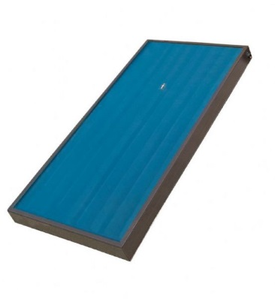**

**Management of the SUN**

Solar concentrators provide high energy density solar radiation to a target receiver, thus raising the temperature of the target. Depending on the degree of concentration, the optical properties (solar absorption and radiation) of the target surface, and the target's cooling rate, the following may occur:

* the target will melt (high concentration);
* the target will reach an equilibrium temperature with natural cooling (modest concentration); or
* the target will reach an equilibrium temperature with a forced (circulating) coolant (intermediate concentration).

The first instance is that of a solar furnace. The second may be considered a solar cooker or solar oven. In the third instance, the heated coolant is used directly as, for example, hot water or steam in home or industrial applications, or indirectly, as a vapor (steam) to generate electricity. In the case of electricity production, common energy conversion devices provide an intermediate step--shaft rotation--between the heated fluid and conversion to electricity. If the target of the concentrated sunlight is a photovoltaic cell, or an array of cells, electricity will be produced directly. The degree of solar concentration, cell conversion efficiency, the design of the cell assembly, and the cell material will determine if natural circulation or forced circulation cooling is necessary for efficient operation of the cell. Currently, the cost/unit area of a concentrator is less than the cost/unit cell area. As a result, concentrators are used to reduce cell area. Should the cell area become less expensive than the concentrator area, concentrators would not be utilized. This paper deals principally with concentrators for thermal applications rather than for applications with photovoltaic cells. Emphasis is placed on applications in less developed countries.

**Sun**

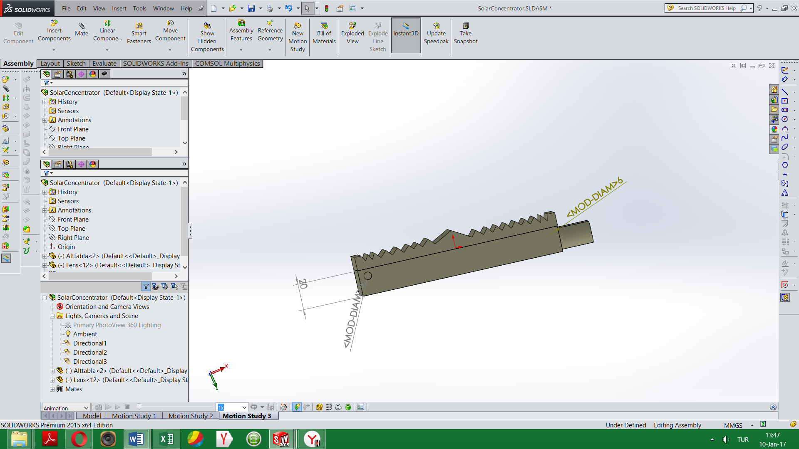 **SUN RAY FOCUSING LENS**

**Sunlight**

**Bottom Plate**

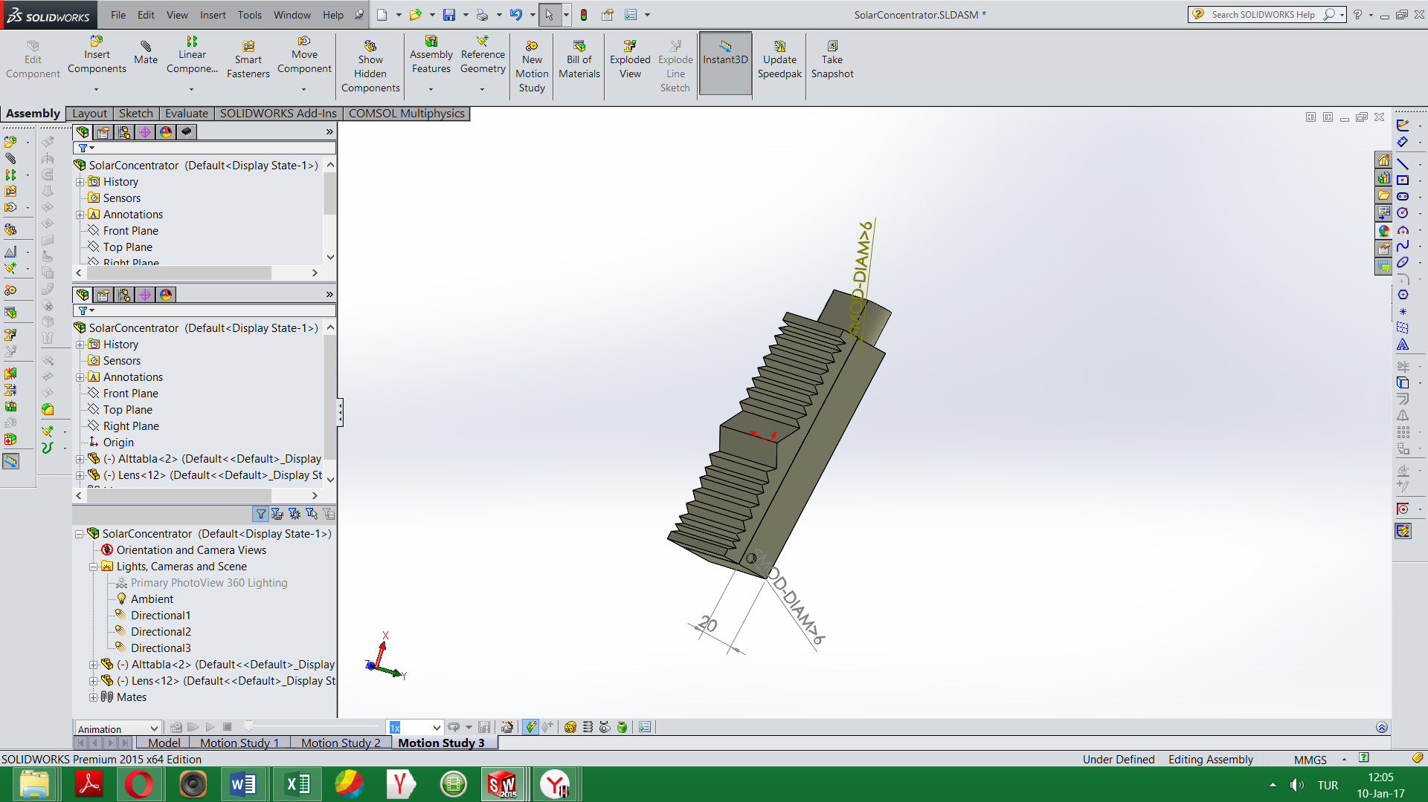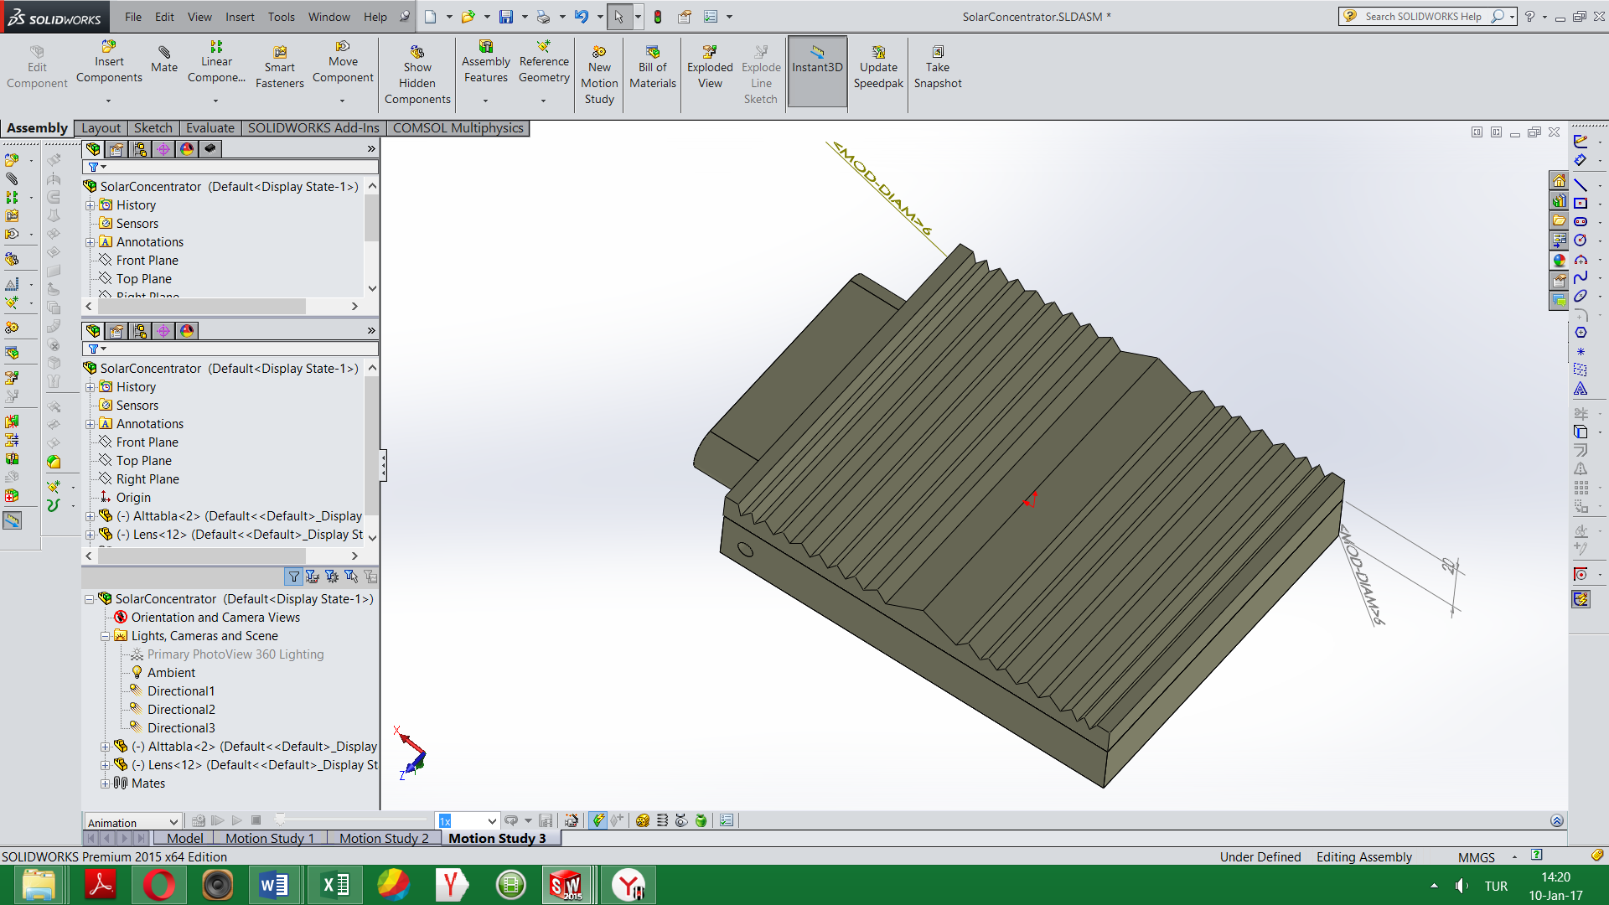

* + 1. **2 3 4 5**
  1. **Cold water entry, 2.) Thermos Systems, 3.) Sun Ray Focusing Systems, 4.)Water tank, 5.) Heat water entry**

**[Sun Ray Concentrator Lens Video1 SunRay Concentrator Lens Video2](https://www.youtube.com/watch?v=nVlb9DY0sfU)**

**R & D Project has been continuing…**

# Pyramid Lens

# C:\Users\user\Desktop\WebSayfası\Pyramide.jpg

**R & D Project has been continuing…**

## **About us**

## **Theorical System Design, Simulation, Modelling and Analysis Department**

## **\* Lens Design and Optical Analysis**

## **\* Optomechanical design**

## **\* Molding design**

## **\* Plastic Injection Simulation and Modelling (Warpage, Cooling, Filling, Package)**

## **\* HibritMesh Analysis**

## **\* Heat Transfer Analysis**

## **\* Optoelectronic Circuit Analysis**

## **\* Plasma System Analysis**

## **\* Chemical Reaction Analysis**

## **\* Mechanical Analysis**

## **\* Database of the Thermoplastic Materials**

## **\* Ultra High Precision CAM Analysis**

## **\* Fiberoptic System Design and  Analysis**

## **\* Thin Film Coating Analysis**

## **\* Fusion Reactor Analysis**

## **Molding, Optical, Optomechanical and Optoelectronics Device Department**

## **C:\Users\user\Downloads\37aebe_405b031d06b3457aabb5f1e92efcb7bc-mv2.jpgC:\Users\user\Downloads\molding.jpgC:\Users\user\Downloads\37aebe_f61a8d37e50d4fcc81501d86b25a25ee-mv2.jpg**

## C:\Users\user\Downloads\37aebe_b87792eedc104ba2a3c71cff7cf47947-mv2.jpg

## **Plastic Injection Department**

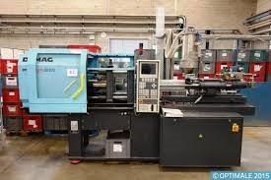 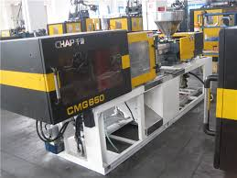 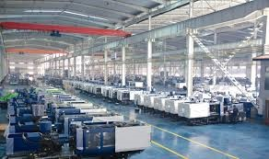

## **Solutions**

 - Developing optical, optoelectronics and optomechanical systems.

- Developing DC and RF plasma systems.

- Design, modeling and production of plastics injection molds, aluminum molds and metal injection molds.

- Design, modeling and production of ultra high precision electrical circuits and mechanical systems.

|  |  |  |
| --- | --- | --- |
|  | **C:\Users\user\Downloads\37aebe_a303835dd115449e97a9bdeb9ec2982d-mv2_d_3543_2953_s_4_2.jpg** | **C:\Users\user\Desktop\globalmarket.jpg** |
| **Strategic Planning**    **Let us help you achieve your goals in the global market by turning your ideas into valuable products.** | **Production**    **Planning the production processes of R&D products is one of the most important developing ideas.**  **Our production ideas have developed the high quality, inventive and out of the limit of imagination.**  **We help our customers to establish production standardisation systems for products with high added value.** | **Global Market**    **We only undertakes research projects for the products that can meet the global market standards.** |

##### **Videos**

|  |  |
| --- | --- |
| [**High Performance Optical System Design**](http://www.youtube.com/watch?v=DecArdQ8G4k) | We design optical systems and develop high-precision polymer based products that are in line with the international standards. |
| [**Advanced molding design**](http://www.youtube.com/watch?v=Z9rsRL-a2yI) | Molding System Simulation and modeling for warpage, cooling, filling, optics analysis. (Using hibritmesh system) |
| [**Heat Transfer, Magnetic Field and Plasma System Analysis**](http://www.youtube.com/watch?v=EFho8j9CA2M) | For all kinds of mechanical and electronic systems, we can design high-precision models, develop simulations and carry out analyses. |

#### **​**

#### **Homepage**

Kuantumek is an innovative R&D company for manufacturer of optical components and systems  such as microscopes, spectrometers, thermoplastic lenses, lenslet array and integrated custom optical systems. We are one of the leading thermoplastic lens and multiple lenses manufacturers in the world. Kuantumek received the Most Promising Company Award, granted jointly by The Union of Chambers and Commodity Exchanges of Turkey (TOBB), Ankara Development Agency and Techno-Initiative Association. We produce cost-efficient optics, optomechanics and optoelectronics systems for several municipalities and large companies of the global market.Kuantumek aims to diversify its product range in order to meet the needs of lighting, energy, health, security, space and aeronatics systems, landing, marine  sectors.